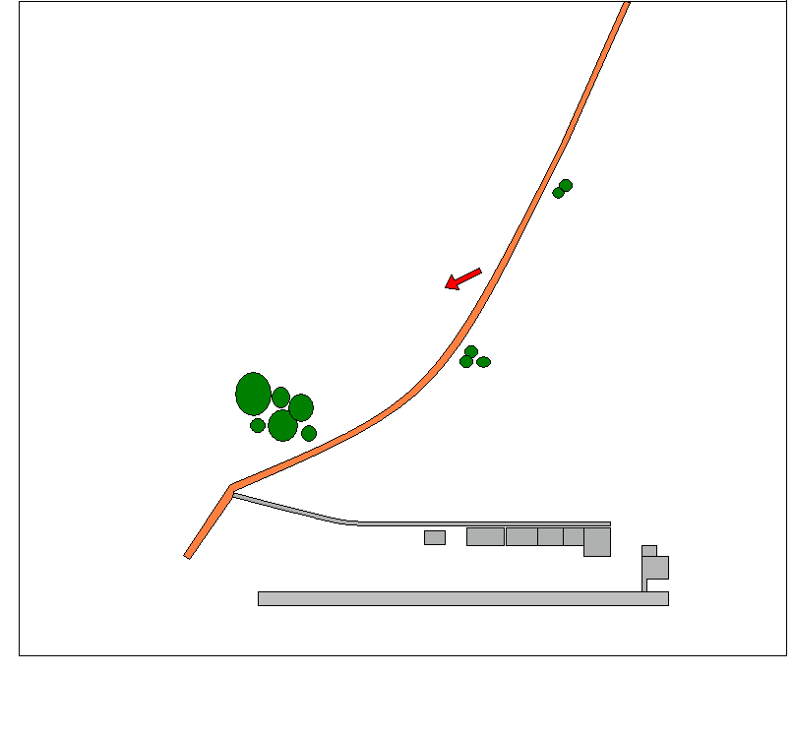

Draw on the diagram your Holding area, your Down Wind, Cross Wind and Into Wind legs for the wind conditions shown.

