The Parachute System Description
Main covering Flap: This is the flap that covers the black Teflon cable going through the nylon loop. Its job is to protect what is beneath it.
Reserve Covering Flap: This is the flap that covers the reserve pin and cable, closure loop and AAD.
Main Handle: This is the handle that opens your main Parachute.
Secondary Handle: This is the handle that the instructors might use to open the parachute (It is not for the person wearing the parachute, they can’t see it or reach it).
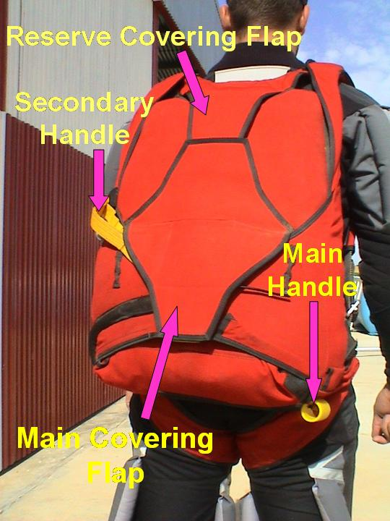

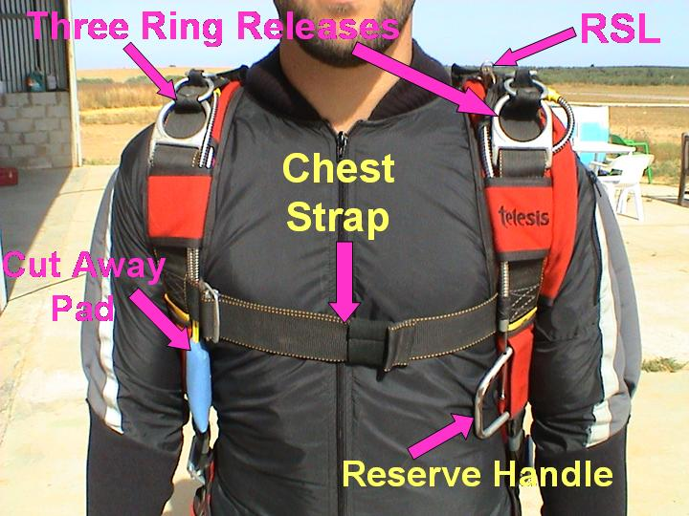
Three Ring Release: This is the system that suspends you from your main risers, and it is also the system used to release you from your main parachute.
RSL: The “Reserve Static Line” will deploy your reserve parachute after cutting away a malfunctioning main parachute (Don’t forget we don’t rely on this, as it’s only a back up system).

Chest Strap: This is the Strap that holds the two side straps together. The routing of the Chest strap is very important and often routed incorrectly.
Cut Away pad: This is the pad that disconnects you from your main parachute if you have a malfunction. It disconnects you at the three ring release.
Reserve Handle: This is the handle that deploys the reserve parachute.

Closure Loop: This is the loop that locks the pilot chute and main parachute inside the container until the Teflon cable has been extracted.
Teflon Cable: This is the cable that is attached to the main handle and when pulled out of the closure loop opens the main parachute.
Secondary Handle: This is the handle that the instructors might use to open the parachute (It is not for the person wearing the parachute, they can’t see it or reach it).
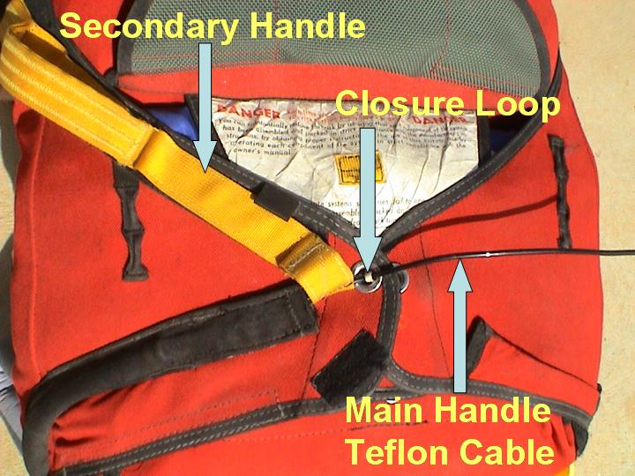

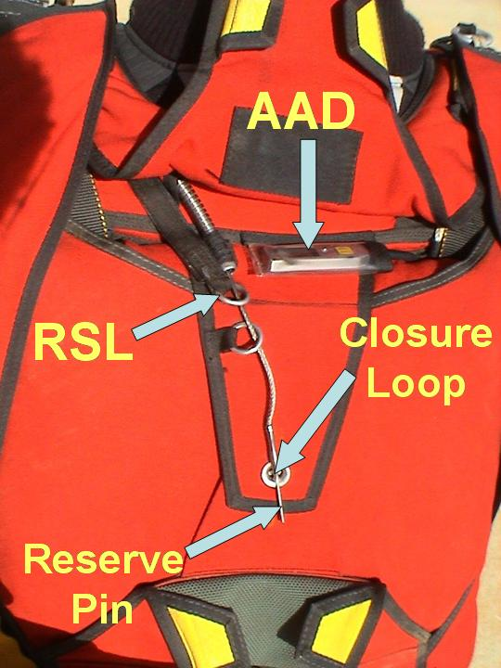
AAD: The Automatic Activation Device will automatically deploy your reserve parachute at 1000 ft if you are falling downwards too fast (Don’t forget we don’t rely on this, as it’s only a back up system).
RSL: The “Reserve Static Line” will deploy your reserve parachute after cutting away a malfunctioning main parachute (Don’t forget we don’t rely on this, as it’s only a back up system).
Closure Loop: This is the loop that locks the reserve pilot chute and reserve parachute inside the container until the reserve pin has been extracted.
Reserve Pin: This is the pin that is attached by a cable to the reserve handle and when pulled out of the closure loop opens the reserve parachute.

