BRITISH PARACHUTE ASSOCIATION www.bpa.org.uk
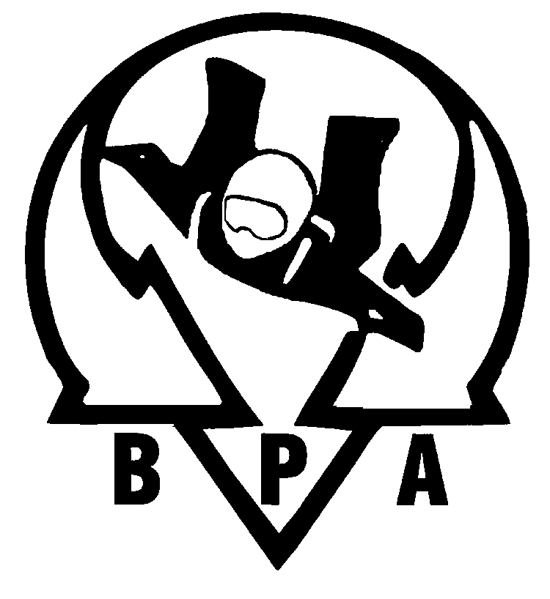
Appendix G
Wharf Way, Glen Parva, Leicester, LE2 9TF
Tel: 0116 278 5271, Fax: 0116 247 7662, e-mail: skydive@bpa.org.uk
_____________________________________________________________________________________________________________

CLUB RISK ASSESSMENT GUIDELINES
to be used in conjunction with Form 244b BPA Club Risk Assessment Form

Introduction to Risk Assessment

A risk assessment is nothing more than a careful examination of what, in your activities, could cause harm to people. You can then decide whether you have taken enough precautions or should do more.

The ideal is to try to make sure that no one ever gets hurt. But accidents do occur. They may have significant adverse effects on your Club in terms of lost income, additional expenditure and loss of goodwill. Poor risk management is just a form of poor management. So there are real benefits - both moral and economic - of getting it right. And, when you do, you start a virtuous cycle of continuous improvement.

As with most exhilarating activities, there are many hazards within our sport of skydiving. So, where should you start… or stop?

What to assess

A ‘hazard’ is defined as ‘something with the potential to cause harm’. Below is a non-exhaustive list of typical hazards associated with the activities of a Sport Parachute Club.

- Active or disused runways
- Hazards associated with jumpers landing - water, trees, buildings, fences, etc
- Canopy collisions in the air
- Canopy collisions with a moving object on the ground
- Aircraft infringements
- Aircraft failure - engine or structural
- Off-landings
- Refuelling procedures - risk of fire; slips, trips and falls
- Hazardous substances - aviation fuels and oils (Control of Substances Hazardous to Health, COSHH)
- Radio failure - student, aircraft, ground
- Parachute failure - AAD, main parachute
- Body entanglement
- Manual handling
- Control of spectators.

The first thing to decide is whether a hazard is significant and whether you have in place satisfactory controls (precautions) so that the risk is small. This should be checked when you assess the risks.

Consider how likely the hazard is to cause harm, and how serious that harm might be. This will determine whether or not you need to do more to reduce the risk. Even after all controls have been put in place, some risks will be likely to remain, but they may well have been reduced.

How to record your assessment

Start by making a list of hazards associated with our sport in general, and then with your Club or Centre in particular. This will make it easier when you come to complete the risk assessment form. You may wish to list everything and then concentrate on those that pose a significant risk where control measures could be improved. The risk assessment form (Form 244b) is in two parts, as follows.

Part A This consists of details of what is being assessed, who is doing the assessment and on what date, etc. It also includes the latest date by which the assessment will need to be reviewed and updated.

Part B (please refer to the form when reading these guidelines) is divided into 6 columns and uses a Risk Level Matrix. This is an easy way of identifying how we can improve the control of risks using pre and post control categories. This will enable you to categorise a risk before and after you have improved its control
__________________________________________________________________________________________________Form 244a (i) Issue 2, Oct 2005
measures. You may find that even with more control measures in place, the risk has not been eliminated or reduced by very much, sometimes hardly at all. Don’t worry - this sometimes happens. It simply means that you need to think some more about the nature of the risk and the strategies for its control.

It is important only to record those control measures that you will actually use, or can implement.

In column 1 of the risk assessment form, record the hazard or activity that may cause harm - such as obstructions, trees, buildings, etc.

In column 2, record who may be harmed by the hazard, such as skydivers or members of the public, etc. You may wish to distinguish between students and experienced skydivers as some risk may be lower to one group than the other.

In column 3, record the pre control risk rating. This is your assessment of how much harm the hazard identified in column 1 has the potential to cause. It is based on the likelihood of something happening, and - if it does happen - how serious the harm is likely to be in terms of severity. Attach a numerical value from 1 to 5 to likelihood and severity and record this within the column, for example 4 (likely) x 3 (significant injury) = 12 (High Risk). A High Risk needs to be reduced.

In column 4, record your existing controls - the precautions you already have in place. Relevant sections of the Operations Manual can be highlighted here, in addition to other controls.

If additional control measures are required, details of these should be set out in column 5. This may consist of references to extracts from your SOPs or new controls that you have identified, to be used in addition to those already in place.

In column 6, record the post control risk rating. This is a new calculation of the likelihood and severity now that you have implemented additional controls (if any). Be honest in your assessment. You may find the risk level does not reduce, as the same risk still remains. Calculate the post control risk rating for each of the other hazards or activities on your list.

If the risk rating does not reduce sufficiently, you may need to consider what additional control measures can be implemented to reduce it further. Discussing the risk with those from other Clubs and Centres can be helpful in developing new or improved risk control measures.

The aim is to reduce all risks and to keep them as low as possible.

Review your assessments

Risk assessments are only useful if they are current. A risk assessment is a living document and if it is filed away on a shelf it will soon become useless.

You must review your risk assessments to make certain that the control measures are still working effectively. The need for a review may be triggered:

- whenever you have a change of aircraft or equipment
- whenever you have a change of people
- whenever you have a change of activities
- whenever there is an amendment to the BPA Operations Manual
- whenever there is an amendment to your Club or Centre SOPs
- after a significant accident or incident, and taking into account any subsequent recommendations made by Boards or Panels of Inquiry, or safety working parties or groups
- when manufacturers’ safety notices or BPA Safety Information Bulletins are issued
- if you suspect that your current assessment is no longer valid for any reason.

Even if everything appears to have stayed the same, risk assessments need routinely to be reviewed at least every two years to make sure they are still current.

Retention of Risk Assessments

Risk Assessments need to be retained for a minimum of five years. They may be audited by the BPA at any time for compliance. They should also be used as part of your safety management system for continuing improvement.
__________________________________________________________________________________________________Form 244a (ii) Issue 2, Oct 2005

