BRITISH PARACHUTE ASSOCIATION

JUMP PILOT MANUAL

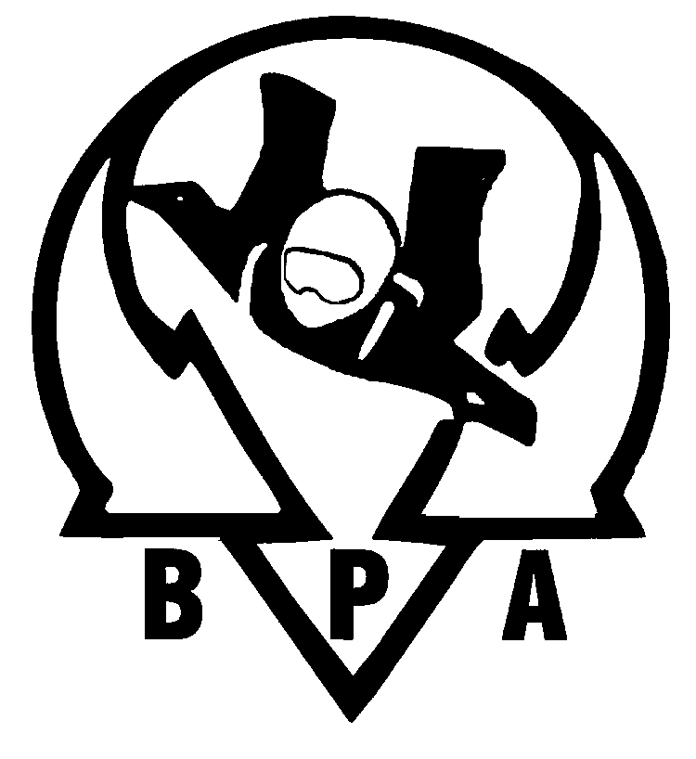

Written by Tony Knight

Approved by BPA Pilots’ Working Group

&

BPA Safety & Training Committee

